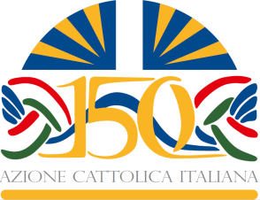

#AC150 Futuro Presente
Rome, Saint Peter’s Square, 30 April 2017

Programme

From 7.00 a.m. Entrance to Saint Peter for all participants

8.00a.m. to 9.30 a.m. Welcome through video, words and music

9.30 a.m. Opening prayer

From 10.00a.m. Three moments of celebration while waiting for the Holy Father:
Catholic Action of the past, of the present and of the future

11.00 a.m. Arrival of the Holy Father and his tour of the square

Greetings from the National President and from the General Assistant

Intervention by the Pope

Regina coeli

